Non Instructor-led Self Learning

15.07.2019

**─**  
Tanmay Deep Sharma Sahil Siddarth LNMIIT, LNMIIT, Jaipur, Jaipur,   
9799968212 9971441320

# Goals: To make self-paced learning efficient and interesting.

# Solution/Innovation:

Learning is the process of acquiring new knowledge. Some of the learning is induced by a single event, but some of them required repeated experiences. Learning technique can be made efficient by the rehearsal. Rehearsal is a cognitive process in which information is repeated over and over as a possible way of learning and remembering it.

We can design an app which would have a problem set of say N problems. There are 5 stages. Initially, all the problems are in the stage-1. One by one, the problems are asked to the user. If the user answers it correctly, then the problem is moved to the next stage, else if the user made a wrong choice, it along with its dependent questions are moved to stage-1. If the user can move all the problem to the last stage, i.e. stage-5, he is done with the course and will be certified with some grade (based on rating algorithm).

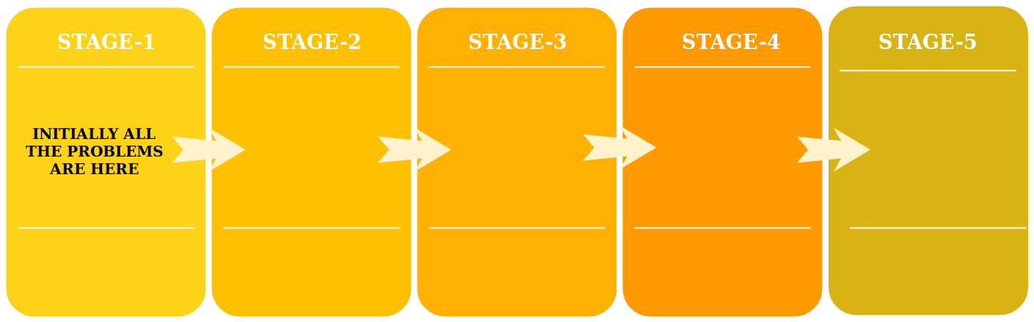

Rating algorithm- (BASED ON GLICKO RATING SYSTEM) Rating of a problem defines its difficulty. Initially, every question and the user is rated the same, say 1500. On every correct answer by the user, there is an increment in the user's rating by some X and decrement in the problem's rating by Y, and vice versa. **Also, at the end of the course, the user will be graded according to his final rating.**

**Sample problem format**->

* Story.
* Question asked on the basis of the story.
* *Options for the following problem.
* Comment section  
    
   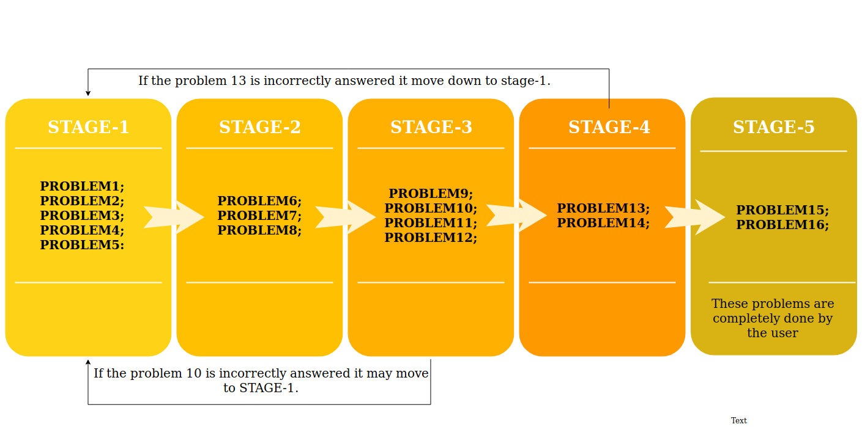

## 

**Every problem will contain some media to make it look more appealing.** If the user gets the answer correct or incorrect, the solution to the problem will be displayed that too in some text+ media format. There will be a public comment section in every question where people can share there analysis/approach, for peers to read, upvote, and downvote

# 

# Advantages:

1. It's a psychologically proven fact that repetition enhances learning activity
2. **Incentives are always a way to attract public.** At every correct answer, we will provide some reinforcement to the user like some virtual coins, and on every wrong answer, we will deduct some coins from his collection. Coins can later be used to retrieve some goodies/prize. Both reinforcement and punishment will increase the learning of an individual.
3. No topic is left unanswered/uncovered.
4. User is graded on the basis of his last rating.
5. Dependent questions are asked after the previous topic is answered.

Above is the dependency graph of problems.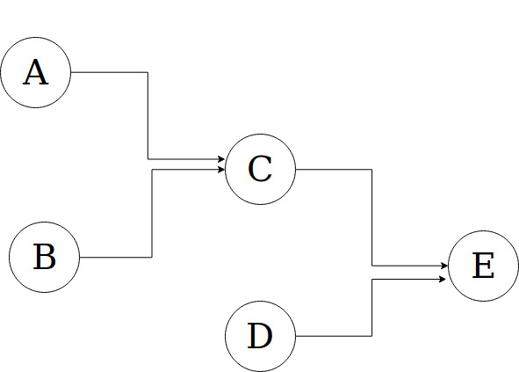

A has to be always asked before C, and E.  
B has to be always asked before C, and E.  
D has to be always asked before E.  
C has to be always asked before E.  
E can only be asked if all previous dependencies are answered correctly.